***Picture Matching***

*Match the name to the picture.*

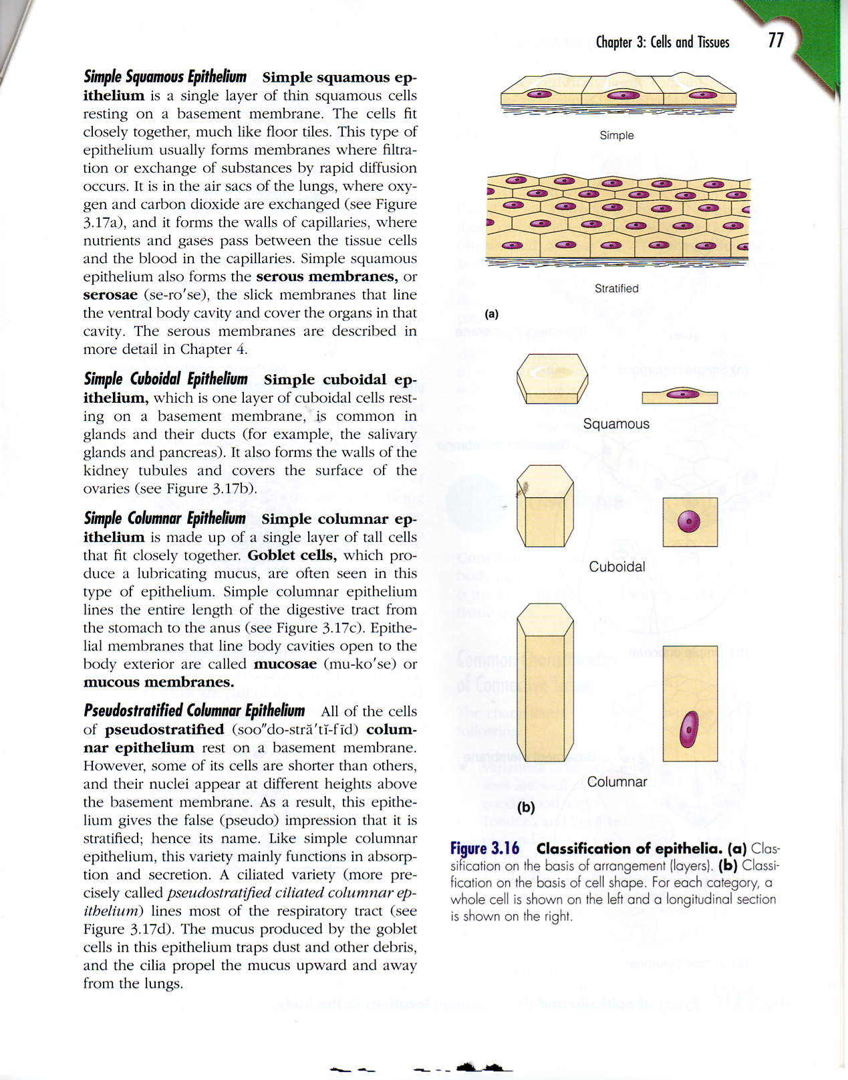

**B**

**A**

**Figure 1**

1. Stratified
2. Simple



**A**

**B**

**C**

**Figure 2**

1. Cuboidal
2. Columnar
3. Squamous



**D**

**B**

**C**

**H**

**G**

**F**

**E**

**A**

**Figure 3**

1. Pseudostratified
2. Simple Columnar
3. Simple Cuboidal
4. Simple Squamous
5. Stratified Columnar
6. Stratified Cuboidal
7. Stratified Squamous
8. Transitional

***Function Matching***

*Match the function(s) to the type of cell. Types of cells can have multiple functions so be sure to choose all the ones that apply to receive credit and fill in the corresponding bubble on your answer sheet.*

1. Simple Squamous
2. Stratified Squamous
3. Simple Cuboidal
4. Stratified Cuboidal
5. Simple Columnar
6. Stratified Columnar
7. Pseudostratified
8. Transitional
9. Diffusion
10. Filtration
11. Secretion
12. Absorption
13. Protection
14. Movement
15. Accommodation of Fluids

***Location Matching***

*Match the type of cell to its location and fill in the corresponding bubble on your answer sheet. Answers will only be used one time.*

1. Simple Squamous
2. Stratified Squamous
3. Simple Cuboidal
4. Stratified Cuboidal
5. Simple Columnar
6. Stratified Columnar
7. Pseudostratified
8. Transitional
9. Intestines
10. Kidney, Mouth, & Vagina
11. Kidney Tubules
12. Mammary Glands
13. Respiratory Tract
14. Sweat Gland Ducts
15. Terminal Bronchioles of Lungs
16. Urinary Bladder, Ureters, Urethra