***Test Information***

Your final exam will cover the entire semester – all 6 units – that were covered. The test is 10 questions and is 20% of your grade. Below, you will find a list of the units that were studied and review questions from each of those units. Of the 100 questions, approximately 25 came from each unit. There will be no short answer questions – all questions will be bubbled in on your answer sheet.

If you complete this entire review packet by the day of your final exam (______________________), you will be allowed to use a note card 3x5 inch note card for the last 40 minutes of the final exam.

***Units Covered***

Unit 1 – The Human Body – An Orientation

Unit 2 – The Cell

Unit 3 – Integumentary System

Unit 4 – Histology (Epithelial & Connective)

Unit 5 – Bone Physiology

Unit 6 – Appendicular Skeleton Anatomy

***Unit 1 – The Human Body – An Orientation***

1. Define:
   1. Anatomy
   2. Physiology
   3. Anatomical position
   4. Development
   5. Homeostasis
2. List the levels of organization from smallest to largest in proper order.
3. List the body cavities and where they are located.
4. Give an example of negative feedback in homeostasis.
5. Circle the body part that corresponds to the directional term:
   1. Distal – elbow or wrist
   2. Superior – nose or chin
   3. Anterior – toes or heal
   4. Inferior – navel or breastbone
   5. Lateral – cheekbone or nose

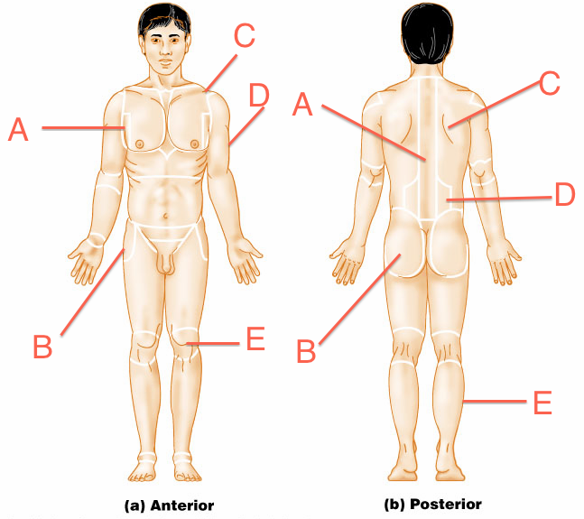

1. Label the figure above with the region of the body that it corresponds to.

***Unit 2 – The Cell***

1. Define each of the following organelles found in a cell:
   1. Cell membrane
   2. Centrioles
   3. Cytoplasm
   4. Nucleus
   5. Nucleolus
   6. Nuclear membrane/envelope
   7. Mitochondria
   8. Vacuole
   9. Ribosome
   10. Rough endoplasmic reticulum (RER)
   11. Smooth endoplasmic reticulum (SER)
   12. Golgi body
   13. Lysosome

***Unit 3 – Integumentary System***

1. List what is contained within the dermis.
2. List the orders of the epidermis from superficial to deep.
3. What is the job of the hypodermis?
4. Define:
   1. Melanin
   2. Keratinocytes
   3. Langerhans cells
   4. Melanocytes

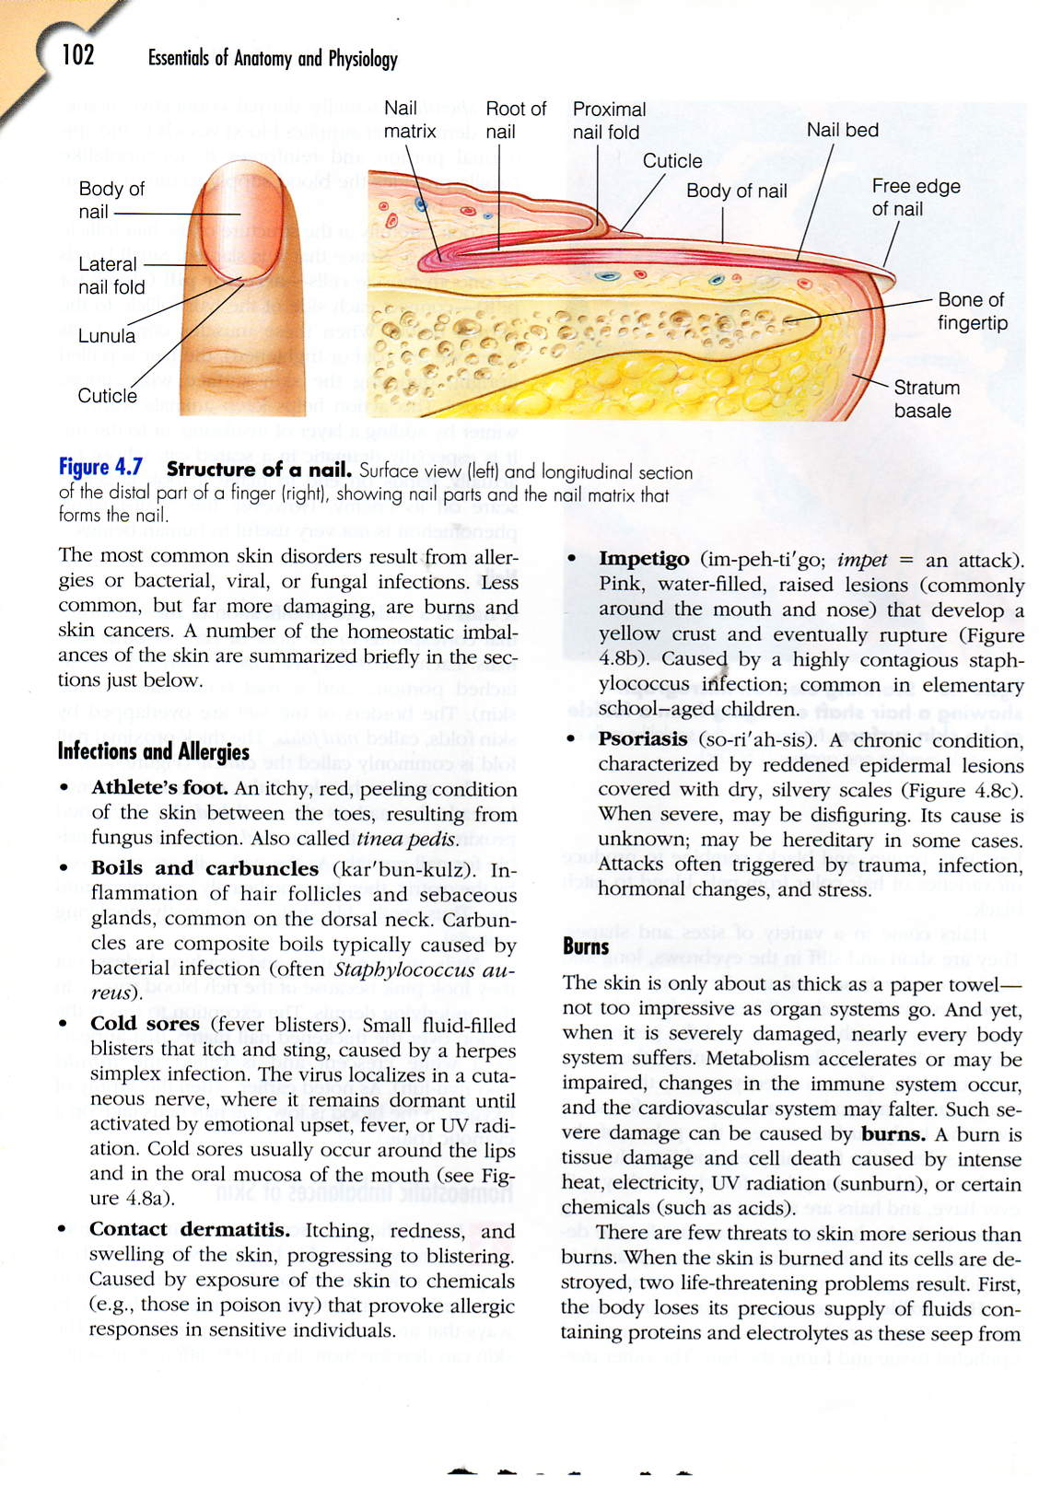

1. Label the picture above.



1. Label the picture above.
2. What is the function of sweat glands?
3. When are sebaceous glands activated?
4. What are the main dangers of burns?

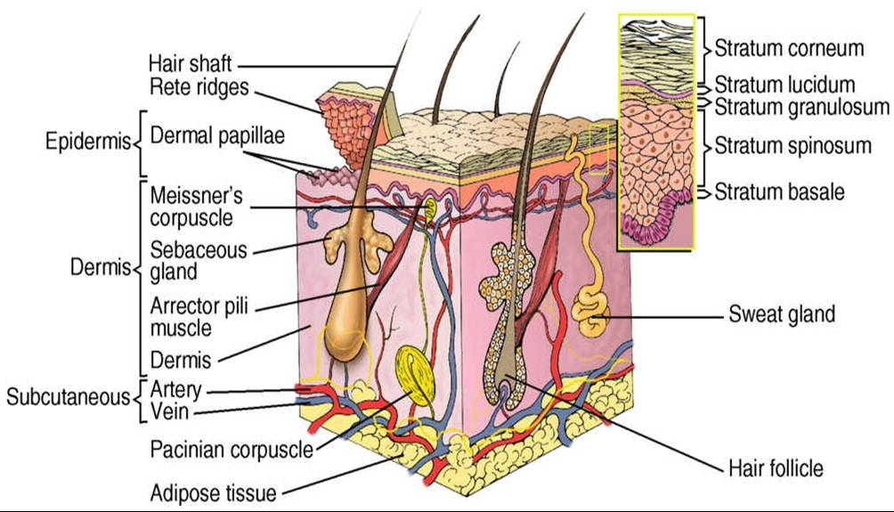

1. Label the figure above where the lines are open at the end.

***Unit 4 - Histology***

1. What is the structure of each of the following epithelial cells?
   1. Simple squamous
   2. Stratified squamous
   3. Simple cuboidal
   4. Stratified cuboidal
   5. Simple columnar
   6. Stratified columnar
   7. Pseudostratified
   8. Transitional
2. What is the location of each of the following epithelial cells?
   1. Simple squamous
   2. Stratified squamous
   3. Simple cuboidal
   4. Stratified cuboidal
   5. Simple columnar
   6. Stratified columnar
   7. Pseudostratified
   8. Transitional
3. What is the location for each of the following connective tissues?
   1. Loose (Areolar)
   2. Dense regular collagenous (DRC)
   3. Dense regular elastic (DRE)
   4. Dense irregular collagenous (DIC)
   5. Dense irregular elastic (DIE)
   6. Hyaline cartilage
   7. Fibrocartilage
   8. Elastic cartilage
   9. Compact bone
   10. Cancellous bone
   11. Reticular
   12. Adipose
4. What is the cell type for each of the following connective tissues?
   1. Loose (Areolar)
   2. Dense regular collagenous (DRC)
   3. Dense regular elastic (DRE)
   4. Dense irregular collagenous (DIC)
   5. Dense irregular elastic (DIE)
   6. Hyaline cartilage
   7. Fibrocartilage
   8. Elastic cartilage
   9. Compact bone
   10. Cancellous bone
   11. Reticular
   12. Adipose

***Unit 5 – Bone Physiology***

1. Define:
   1. Osteoprogenitor cells
   2. Hyaline cartilage
   3. Osteoblast
   4. Osteoclast
   5. Osteocyte
   6. Ligament
   7. Tendon
   8. Articular cartilage
2. What is the function of red marrow?
3. List the 5 functions of the skeletal system.
4. In which type of bone would trabeculae be present?
5. What stimulates interstitial cartilage and appositional bone growth?
6. List the 4 steps of bone repair in order.
7. What is the shaft of a bone called?
8. What is the primary mineral in bone?
9. What is the area where marrow is located in a bone?



1. Label the figure above.

***Unit 6 – Appendicular Skeleton Anatomy***

1. How many bones are in the adult human skeleton?
2. What is the longest bone in the body?
3. List the 3 parts of the appendicular skeleton.
4. List the 7 bones of the wrist.
5. What is another name for wrist?
6. Describe where the following bones are located?
   1. Humerus
   2. Femur
   3. Tibia
   4. Fibula
   5. Radius
   6. Ulna
   7. Clavicle
   8. Scapula
   9. Calcaneus
7. List the bones of the pelvic girdle.
8. Which is the process that allows the arm free movement?
9. List the major parts of the axial skeleton.
10. How many bones are in:
    1. One of your wrists and hands?
    2. The appendicular skeleton?